131)Based on the sample code above,which line of code do you insert in place of ??? for the function properly?

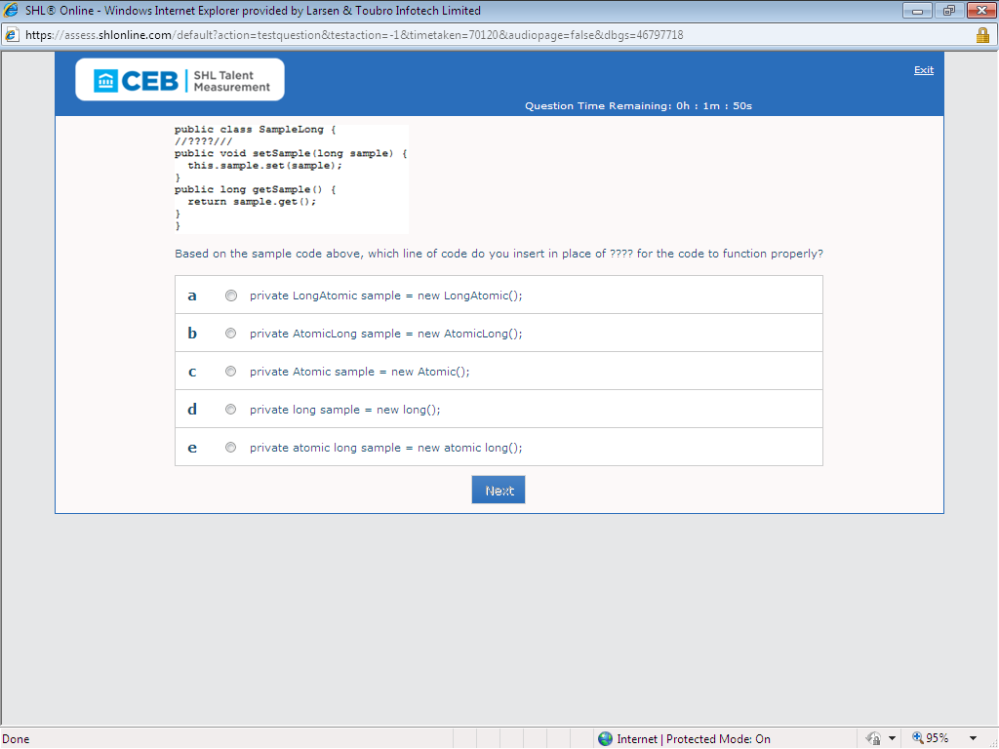

Ans:B

132)Assuming the main method is static, why does the sample code above not produce a compile error?

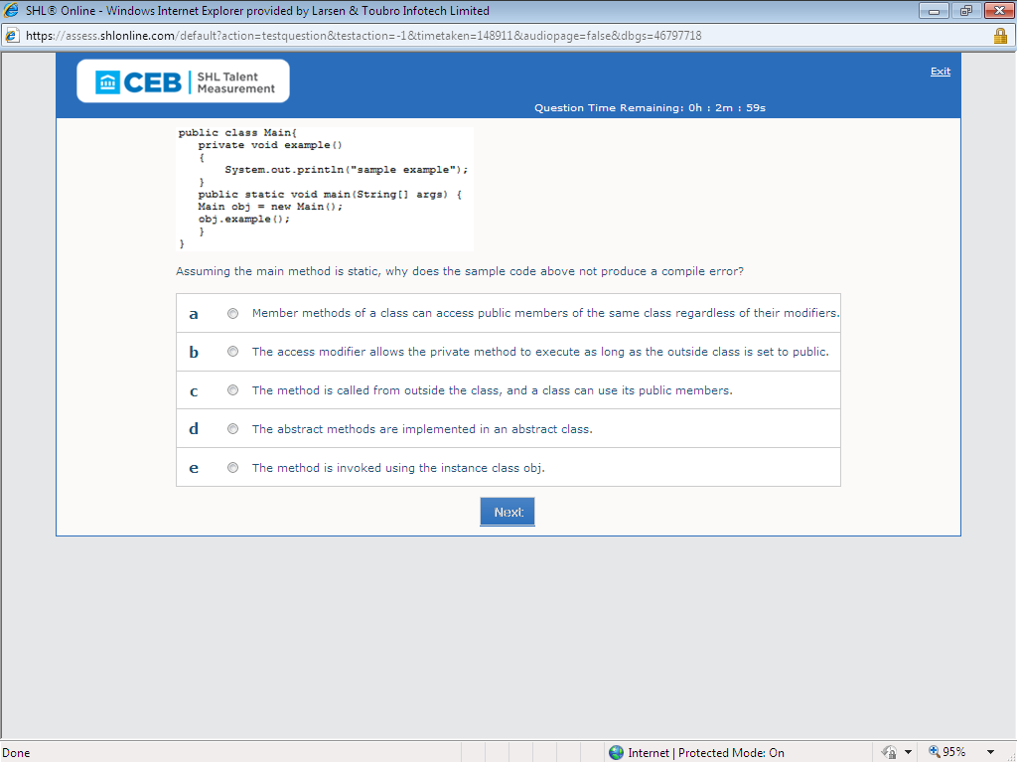

Ans: e

133)While starting a VM you receive the following error: “Error occurred during …..error?

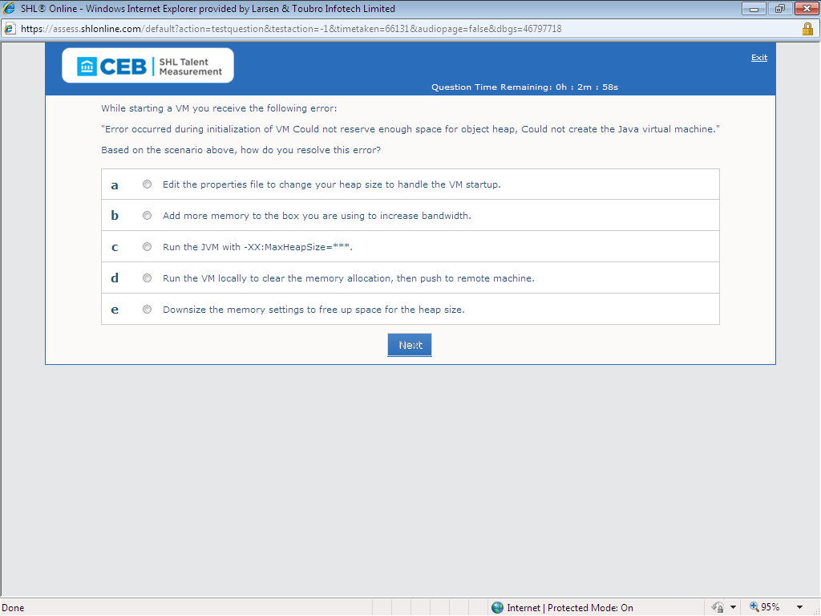

Ans:C

134)How do you fix the sample code above for it thrown an exception?

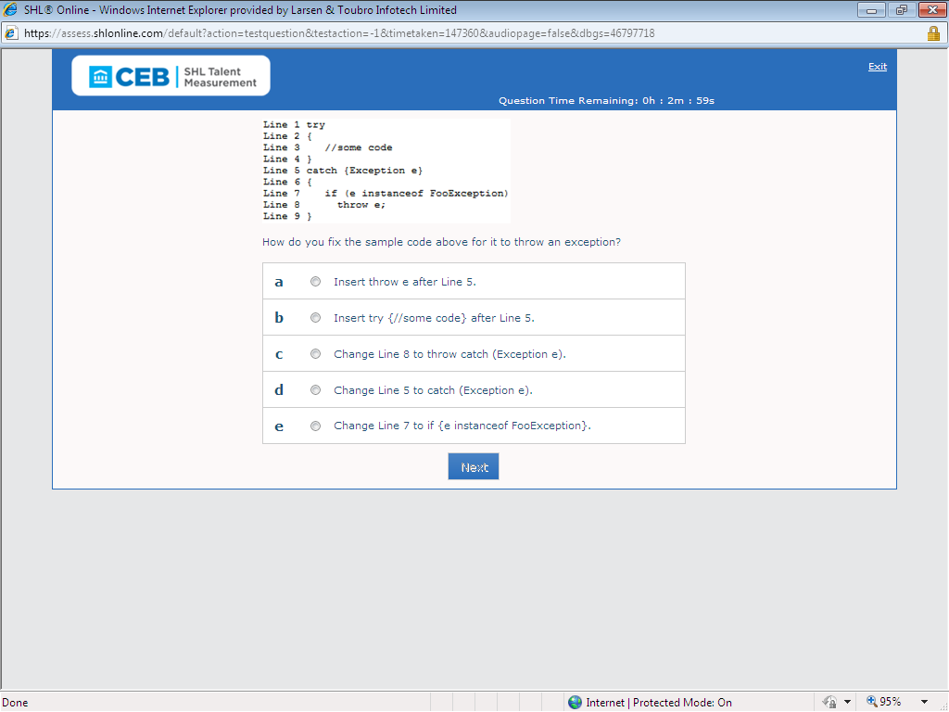

Ans:C

135)How do you rewrite the sample code above to optimize linear concatenations?

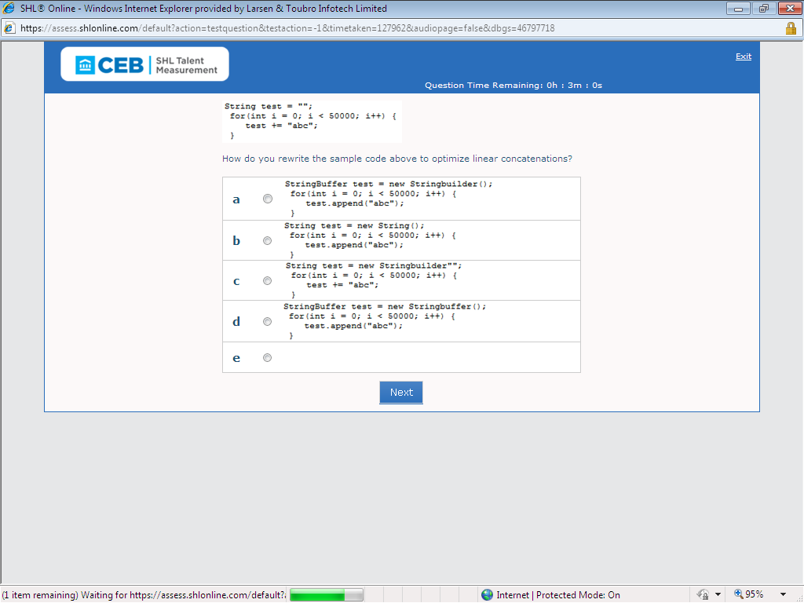

Ans: e

136)How do you operate the sample code above operate?

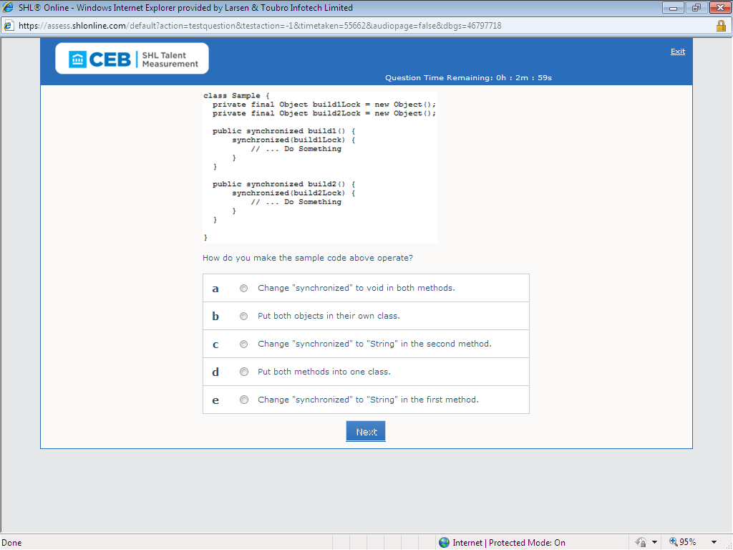

139)based on the sample output from the compiler above, what is the error in the code?

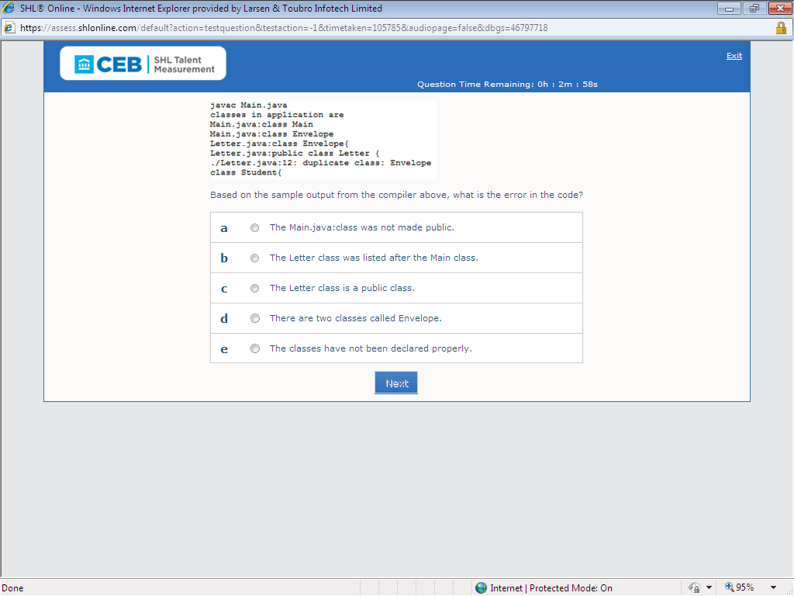

140)Which class do you use to manage a list of listeners for a JavaBean component?

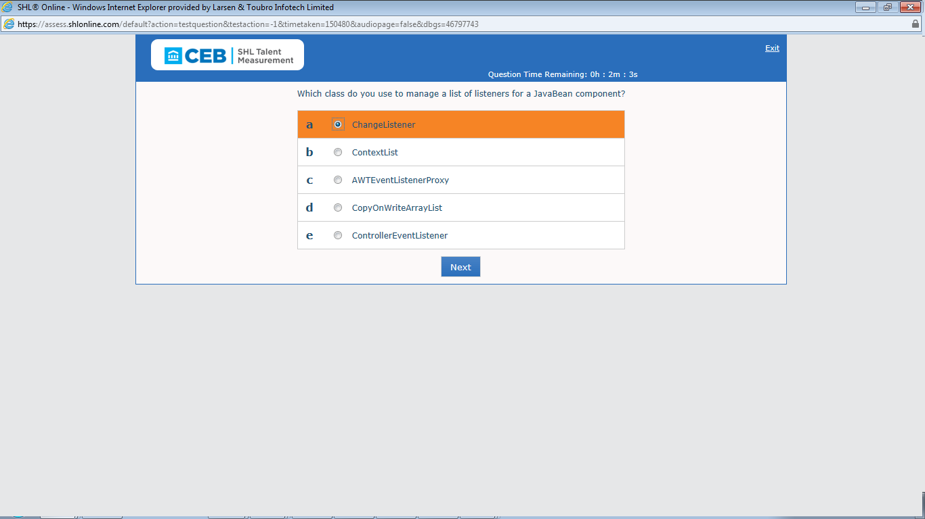

Ans: A

141)given in the sample code above , what needs to be executed for the code to execute?

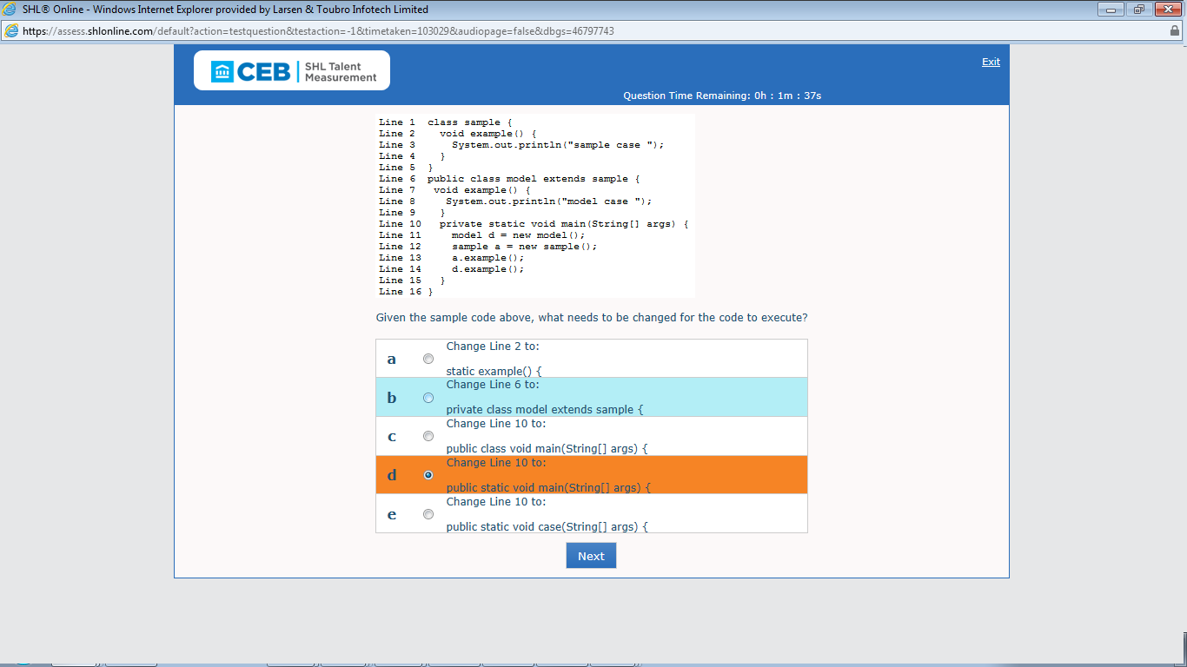

Ans: D

142)Which line in the sample code above contains the compile-time error?

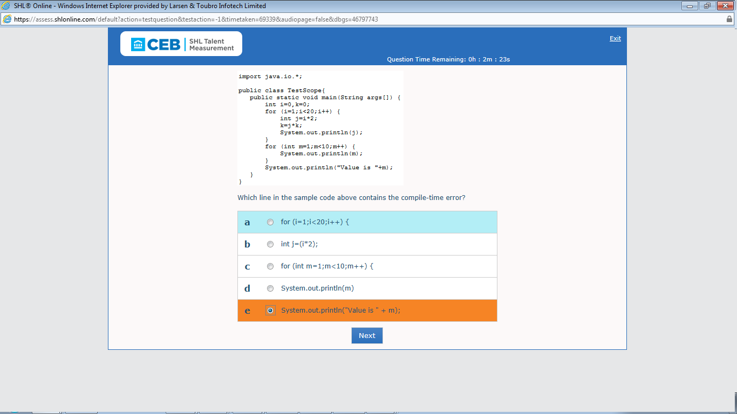

Ans: E

143)which code snippet do you insert above line 1 in the sample code to complile the creation of a custom annotation?

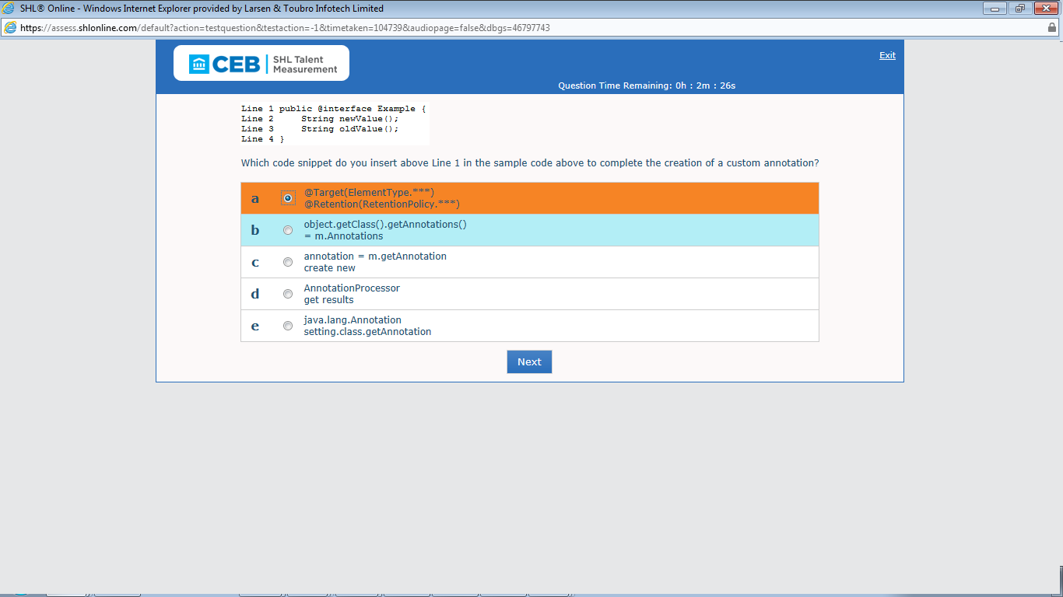

Ans: A

144)Which line of code do you add to compile the sample code above?

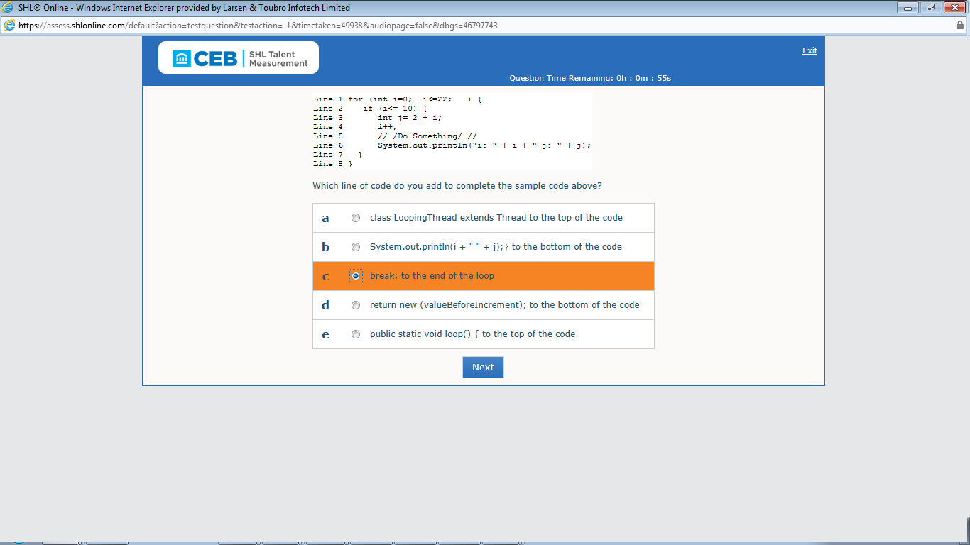

Ans: C(needs to check in eclipse)

145)A program has numerous services and DAO classes that have the same 30-line exception …..refactor the code?

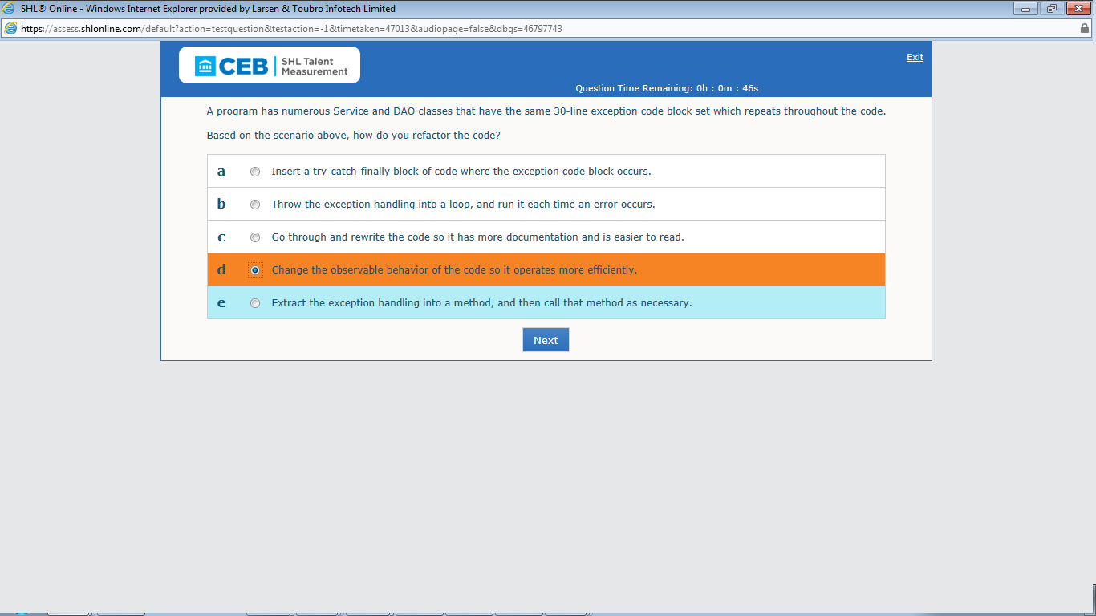

Ans: D

146)what is printed when the sample code above is executed?

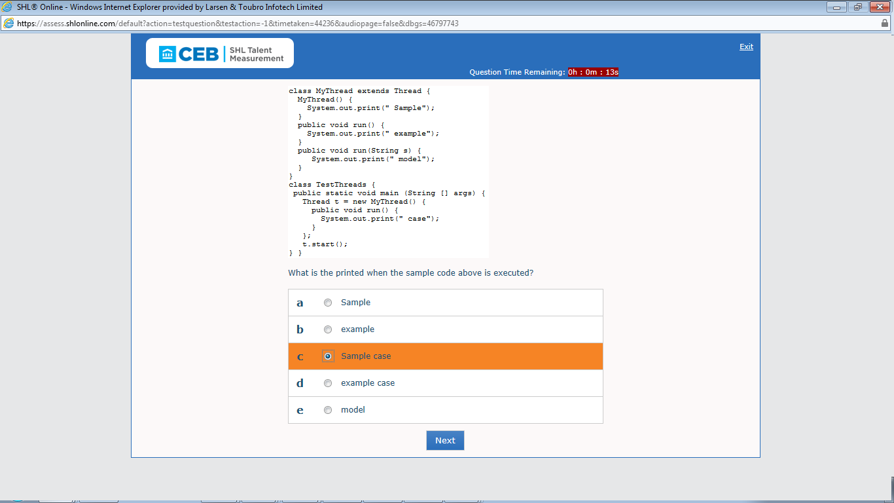

Ans: C

147)which is required for refactoring to take place?

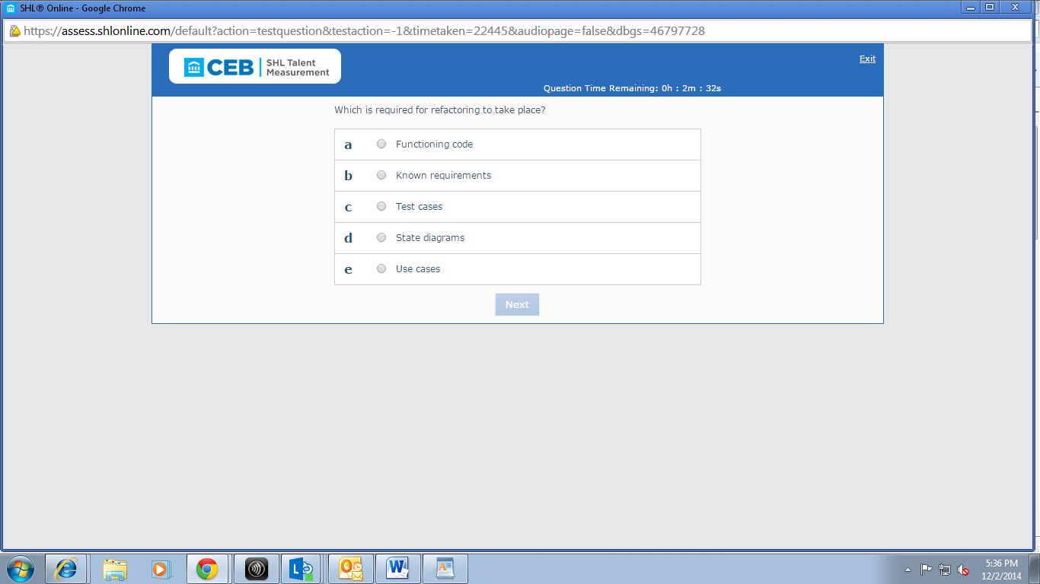

Ans: c

148)which change do you make to the sample code above to add values to both example arrays?

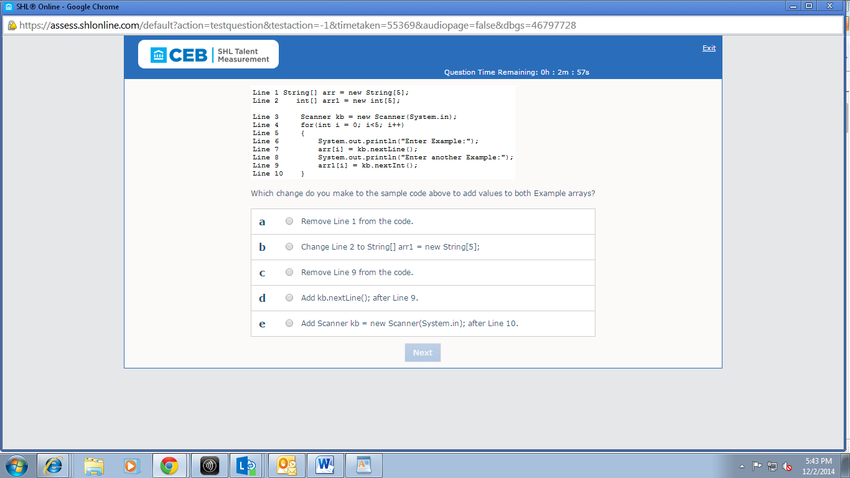

149)Based on the sample code above, how do you start the debugger and then set a breakpoint in the code?

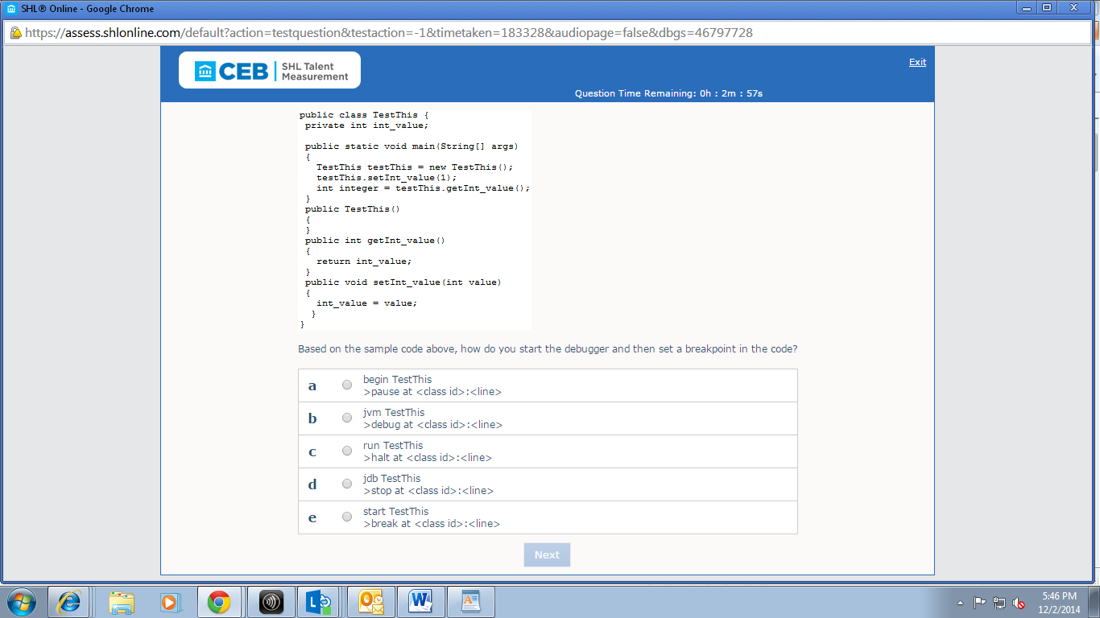

150)why does the sample code above fail to compile?

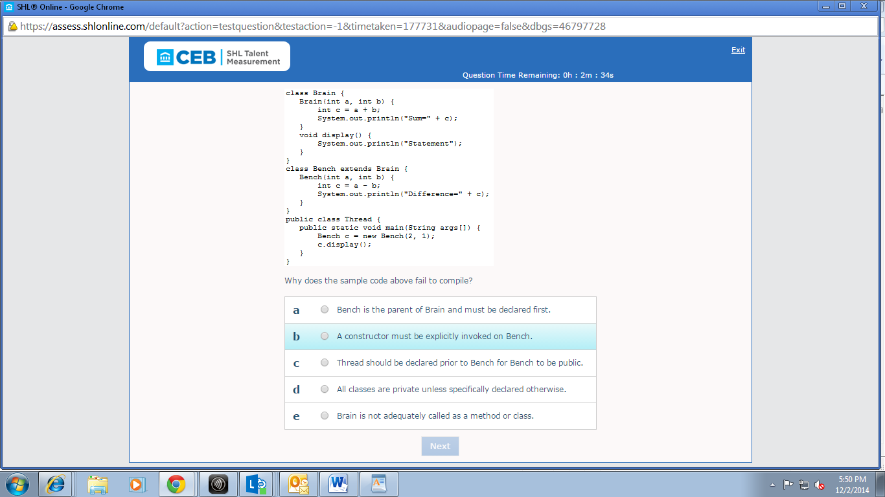

151)How do you save encrypted version of a serialized object?

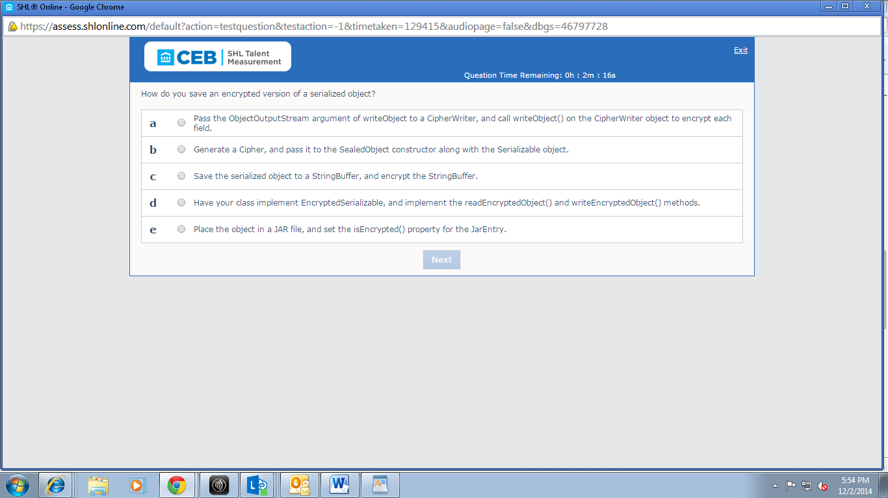

152)why does the sample code above produce an error?

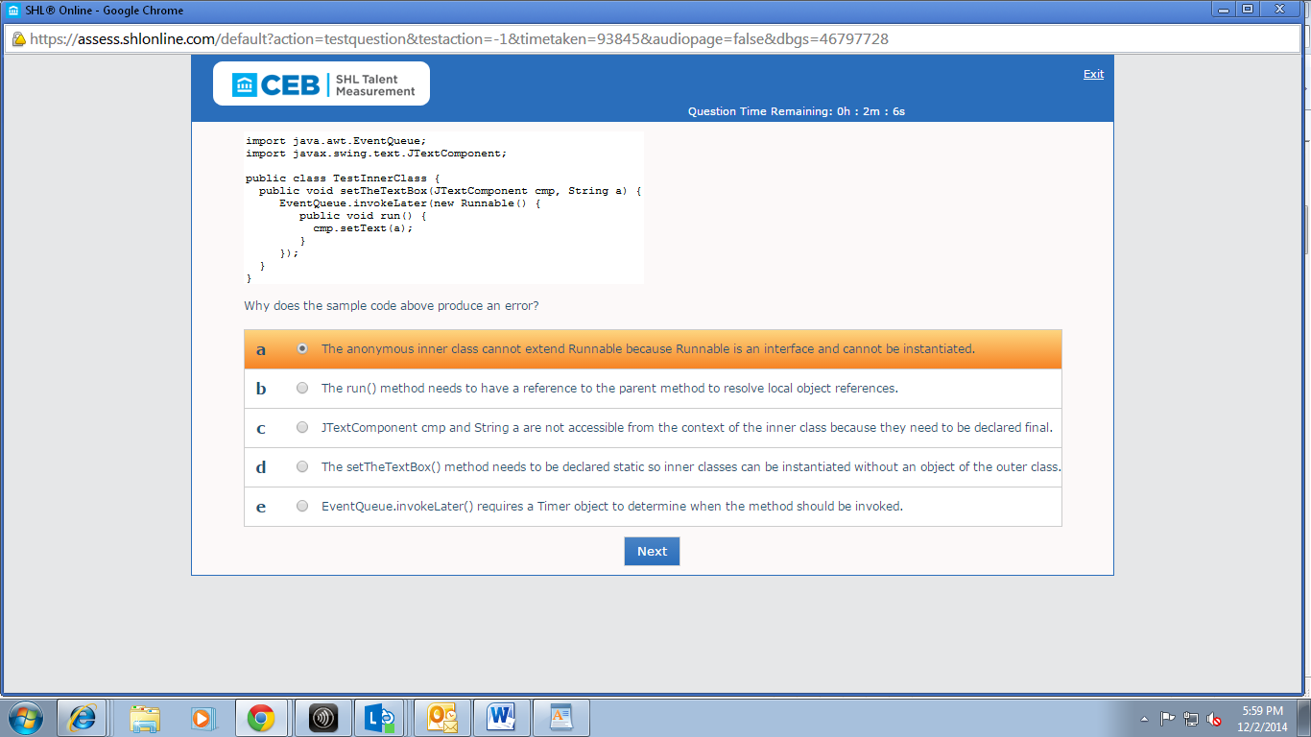

153)The windowsListener in the sample code above exhibits which behavioral pattern?

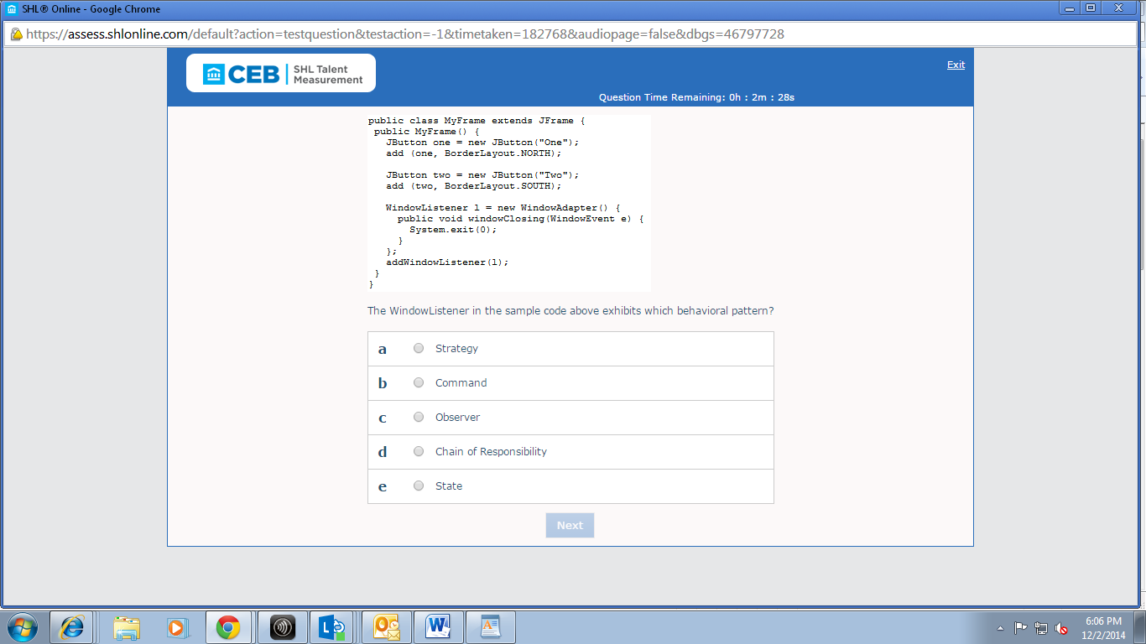

154)which command line do you use to load the JDWP agent for debugging ?

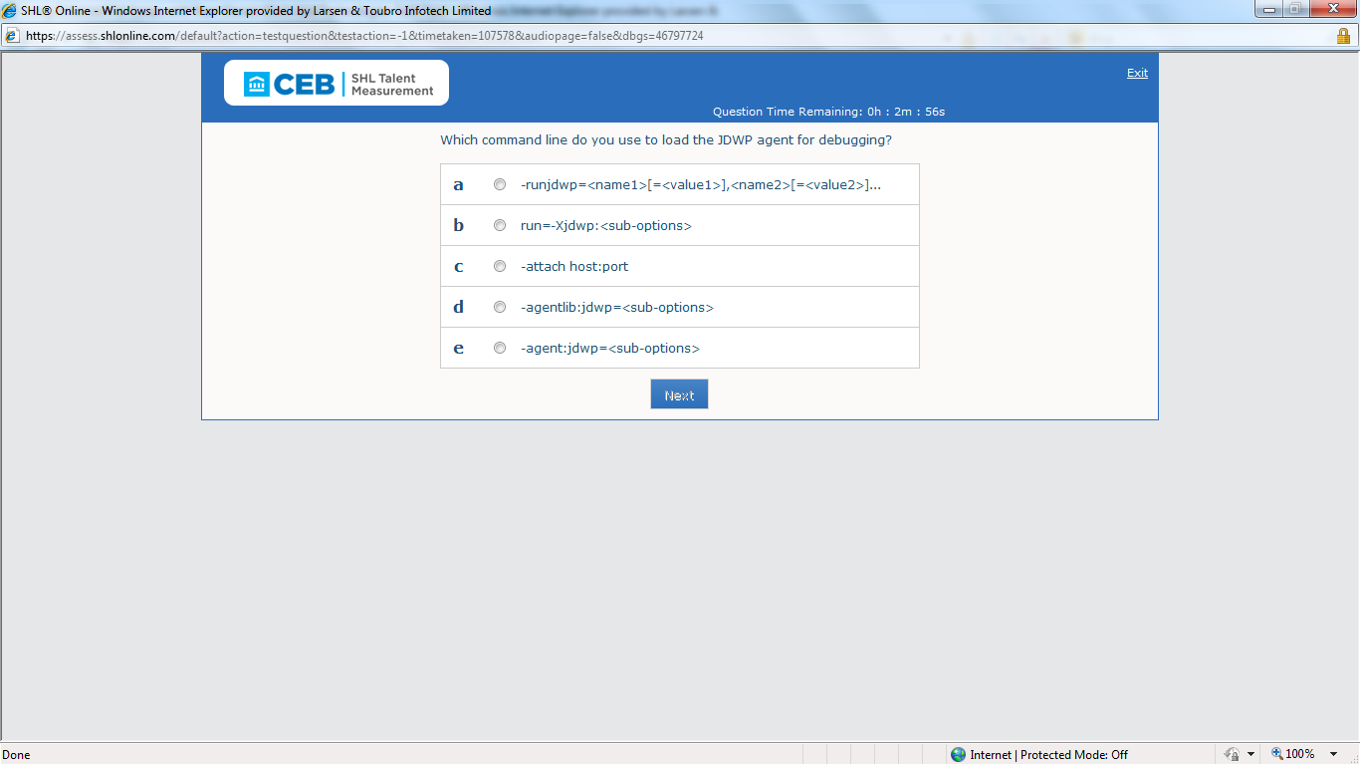

Ans: D

155)In the sample code above, after execution, what does the array named bArray contain?

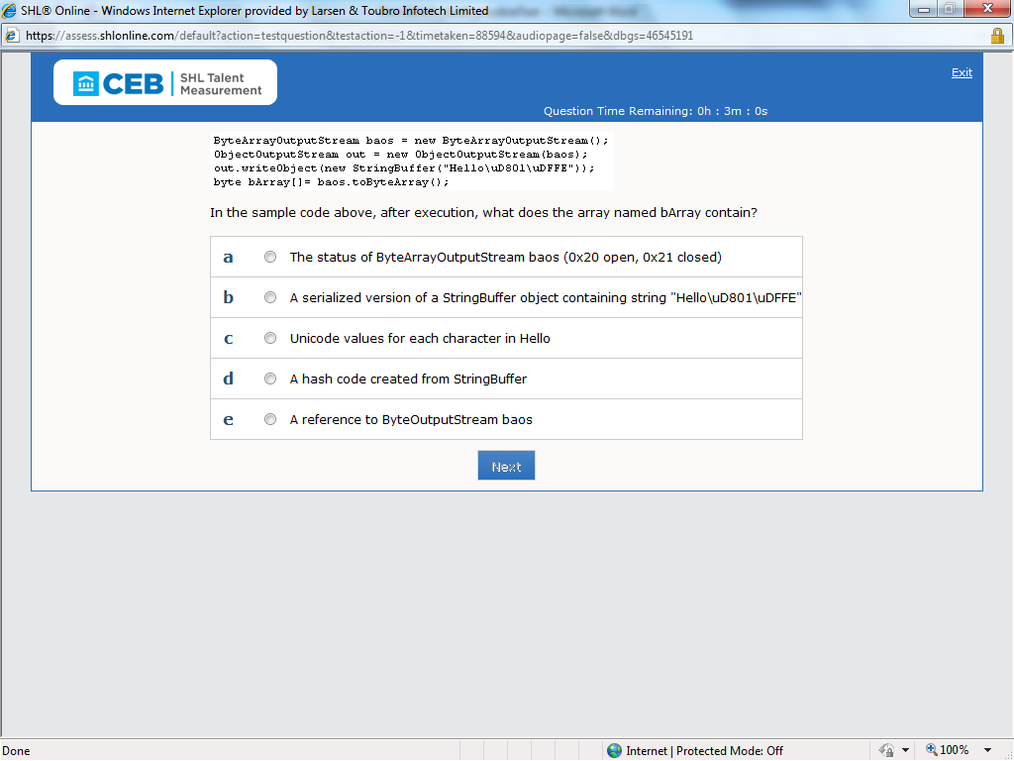

Ans: D

156)Which one of the code sequences is the XML tree for the document created with the sample code above?

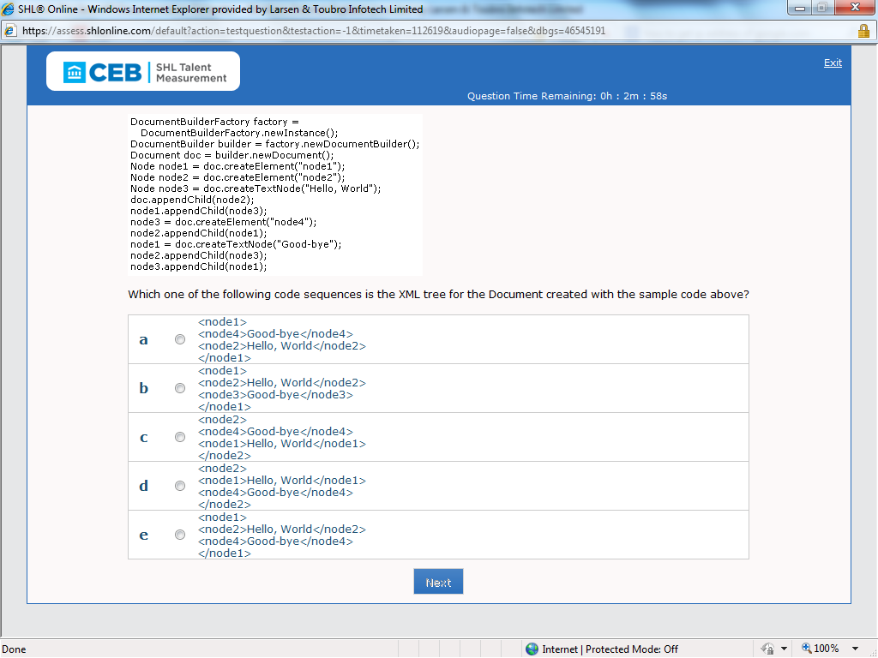

Ans: needs to check in eclipse

157)which line of code do you add to complete the sample code above?



Ans: C;

158)

|  |
| --- |
| You are deploying an application via Java Web Start. The JAR files are signed. You want the client to get full system access when trusted by the user. |
| Referring to the scenario above, which elements do you add to the JNLP file? |
| <permission>    <all/> </permission> |
| <security>     <all-permissions/>  </security> |
| <security>     <permission=AllPermission/>  </security> |
| <permission>    <java.security.AllPermission/> </permission> |
| <security>     <*/>  </security> |

Ans: <security> 
   <all-permissions/> 
</security>

159)

|  |  |
| --- | --- |
| List<Double> doubles = new LinkedList<>(); List<Integer> integers = new LinkedList<Integer>(); ... List<String> doubleValues = getValues(doubles); List<String> intValues = getValues(integers); |  |
| Given that Double and Integer are subclasses of Number, which declaration of the getValues() method in the sample code above will compile without errors or warnings? |  |
| List<String> getValues(List<? extends Number> list) |  |
| public List<String> getValues(getlist) |  |
| public List<Number> getValues(List<String> list) |  |
| public List<String> getValues(List list) |  |
| public List<String> getNumbers(List<Value> list) |  |

Ans: List<String> getValues(List<? extends Number> list)

160)

|  |  |
| --- | --- |
|  |  |
| String strCase1 = someTest.getSomeProperties1();  strCase1 = doSomething(strCase1);  String strCase2 = someTest.getSomeProperties2();  strCase2 = doSomething(strCase2);  String strResult = strCase1 + strCase2;  someTest.setSomeProperties(strResult); |  |
| How do you refactor the sample code above to function the same? |  |
| someTest.setProperties(  doTest(someResult.getSomeProperties1()) + doTest(someResult.getSomeProperties2())); |  |
| someTest.setSomeProperties(  doSomething(someTest.getSomeProperties1()) + doSomething(someTest.getSomeProperties2())); |  |
| someCase.setSomething(  doSomething(someCase.getSomeResult1()) + doSomething(someCase.getSomeResult2())); |  |
| someProperties.setSring(  doSomething(someCase1.getSomeProperties1()) + doSomething(someCase2.getSomeProperties2())); |  |
| someResult.setSomething(  doCase1(someProperties.getStr()) +  doCase2(someProperties.getStr())); |  |

Ans:

|  |  |
| --- | --- |
| someTest.setSomeProperties(  doSomething(someTest.getSomeProperties1()) + doSomething(someTest.getSomeProperties2())); |  |

161)what is the output of the sample code above?

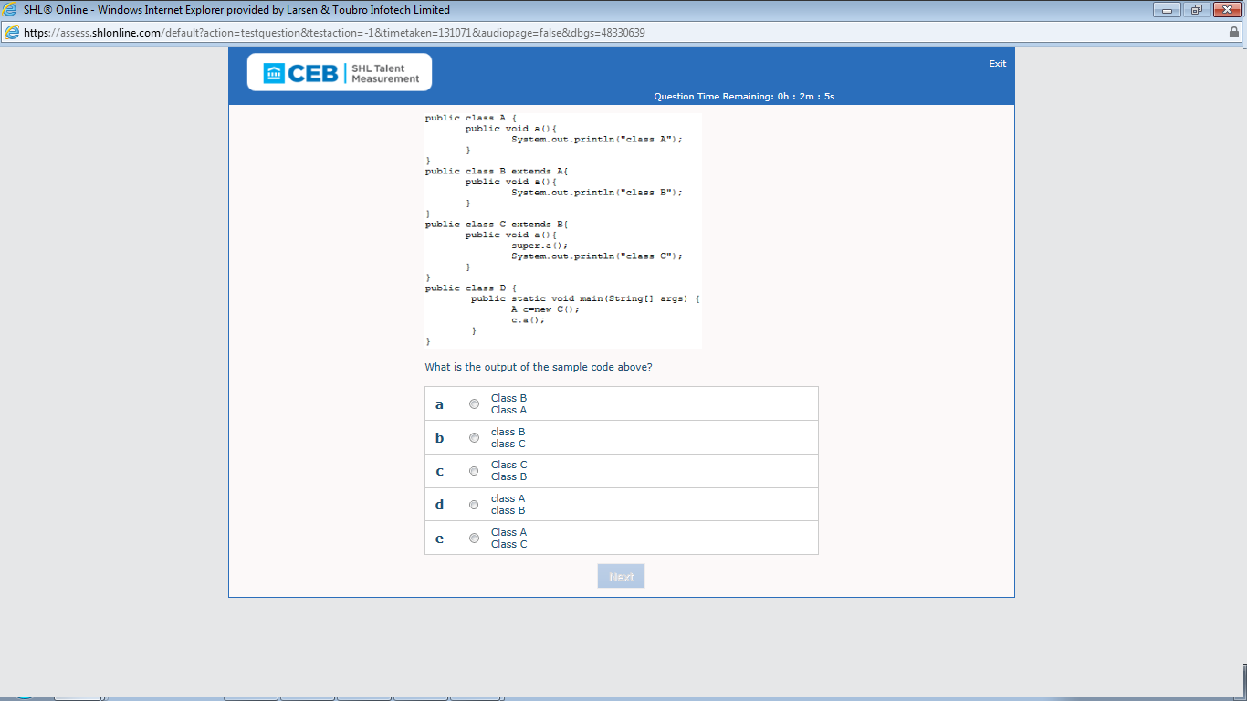

Ans: B

162)you perform Localization by:

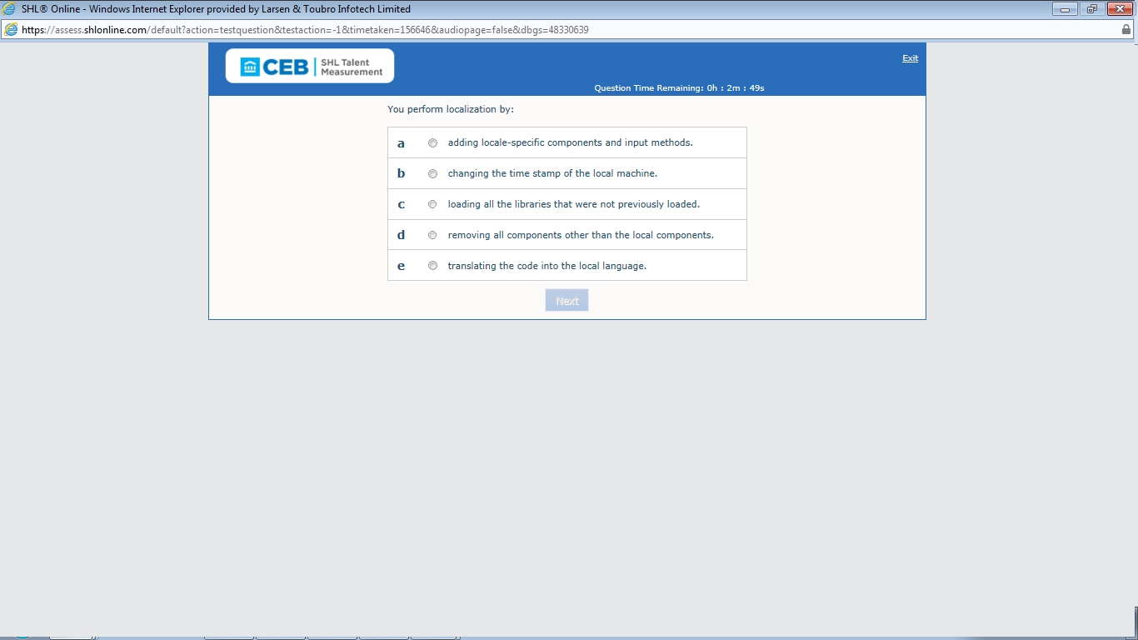

Ans: E

163)which do you change in the sample code above to eliminate the error:”java.lang.ArrayIndexOutOfBoundexception:coordinate out of bounds”?

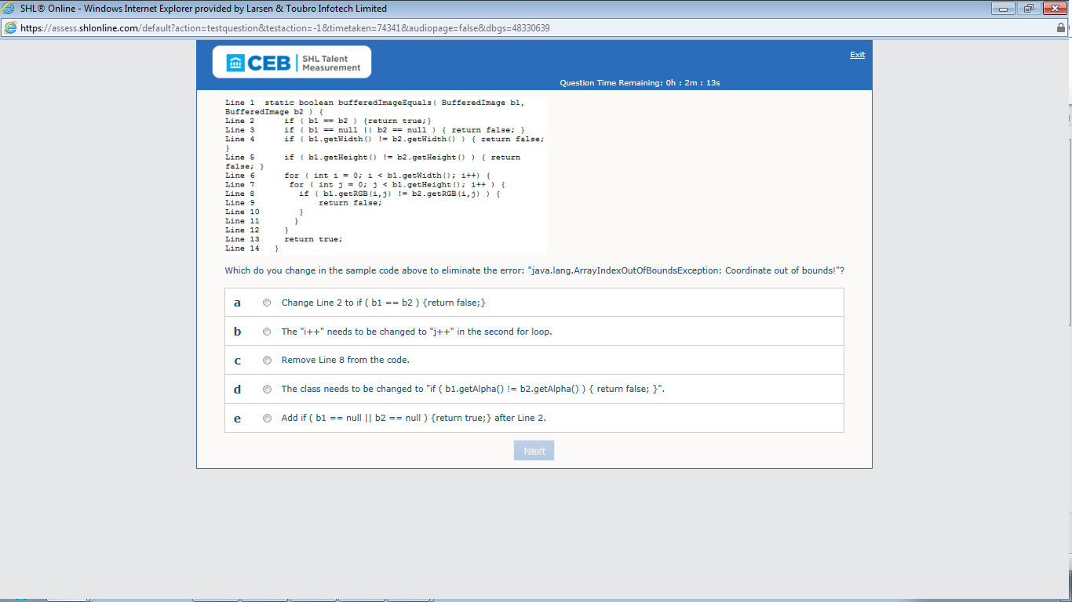

Ans: B

164)what is the result of executing the sample code above?

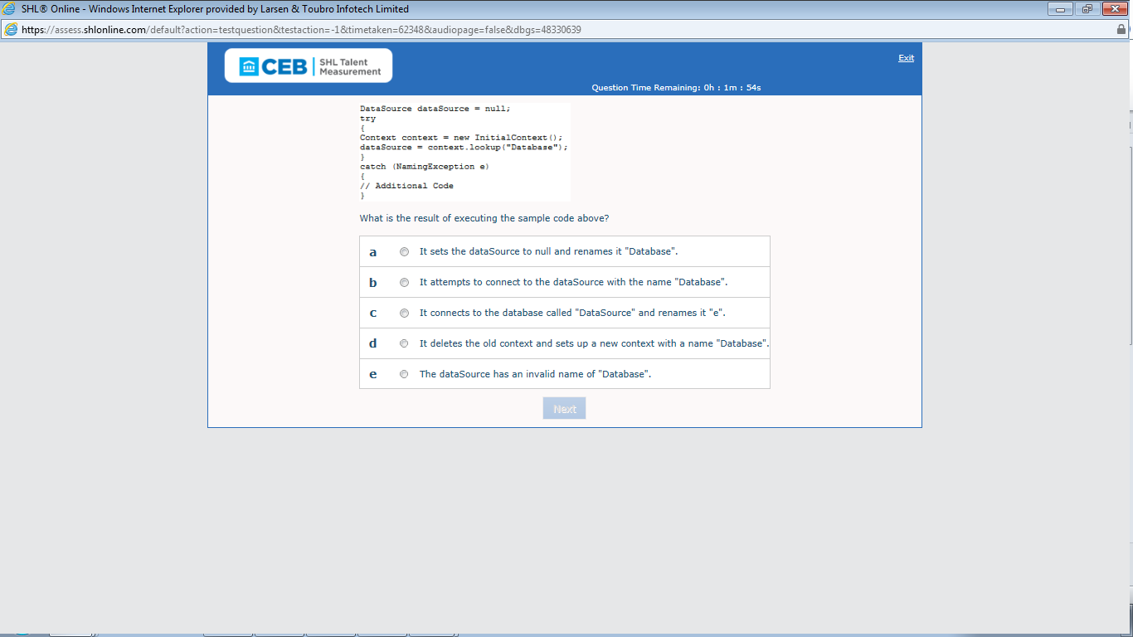

Ans: B

165)what is the outcome of the sample code above?

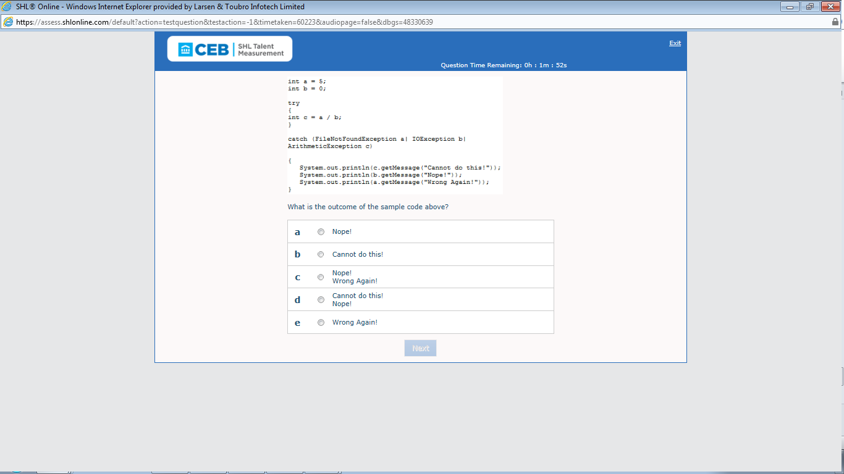

Ans: B(needs to execute this in eclipse)

166)Which one of the following requirements must a class meet In order to be written to a stream using ObjectOutputStream?

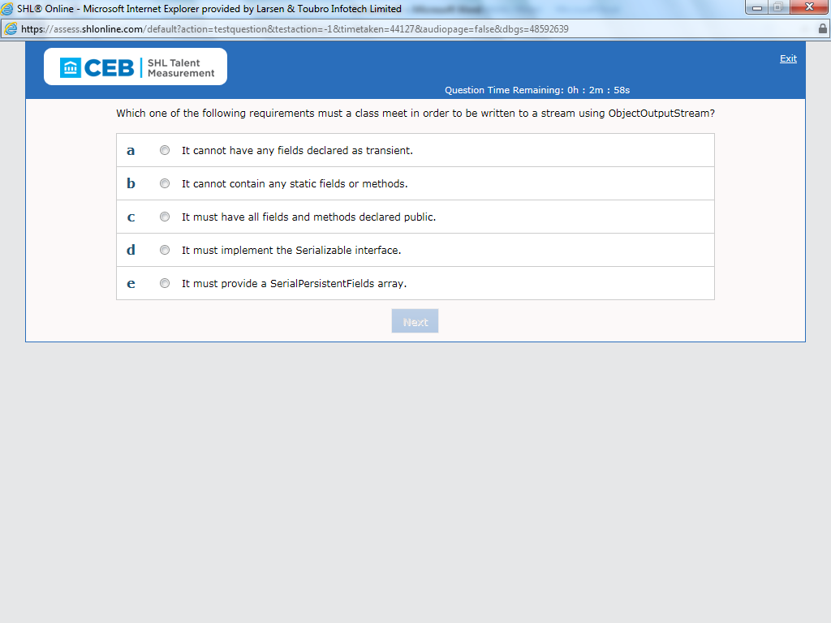

Ans: D

167)When an applet runs inside a Web browser’s virtual machine, when is the applets’ destroy() method called?

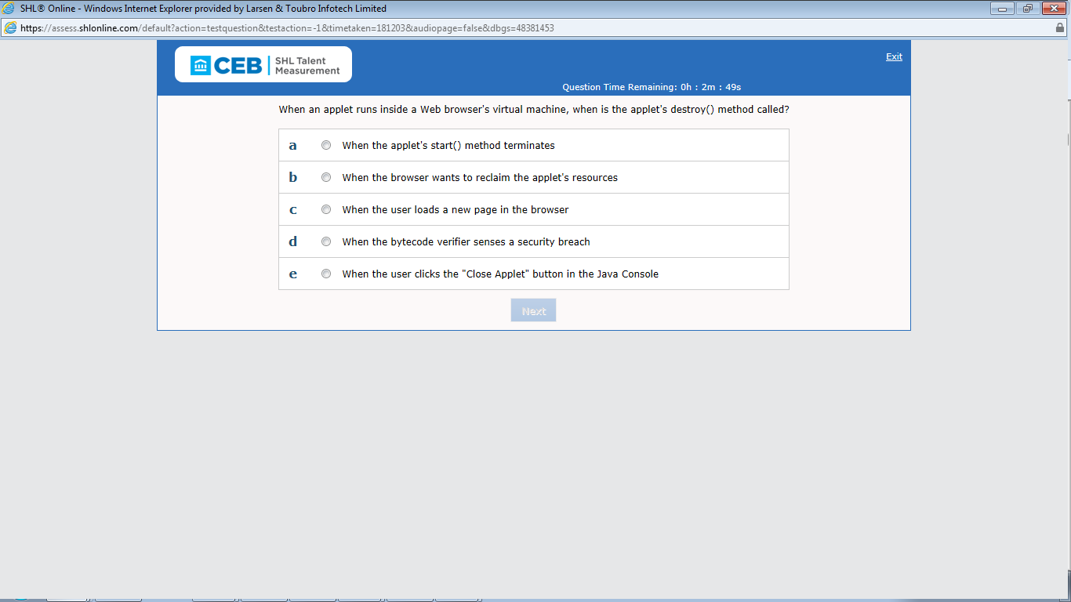

Ans: E

168)which one of the following code sequences do you use to turn off text antialliasing before you display the text in the sample code above?

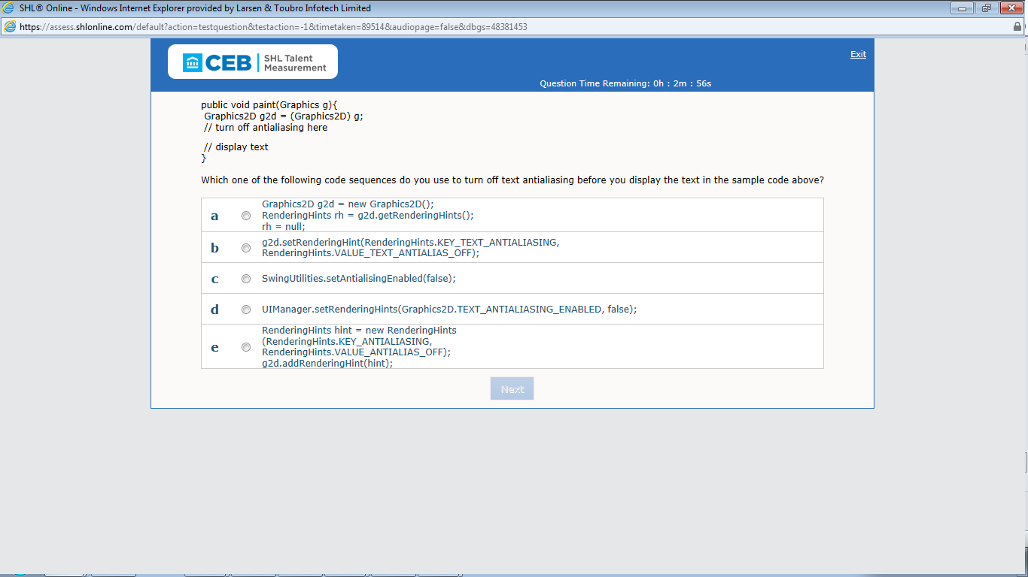

Ans: B

169)what must you add to the sample code above in order to get the first brainbench node from the DOM tree before dumping its subtree?

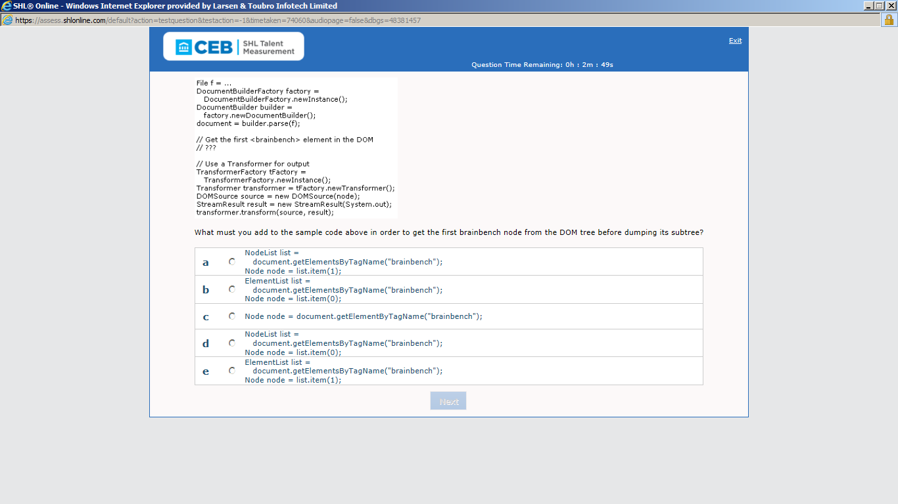

Ans: D